SQL HR_Analytics Question And Answer

1. **List all employee details:**

SELECT * FROM HR_Analytics;

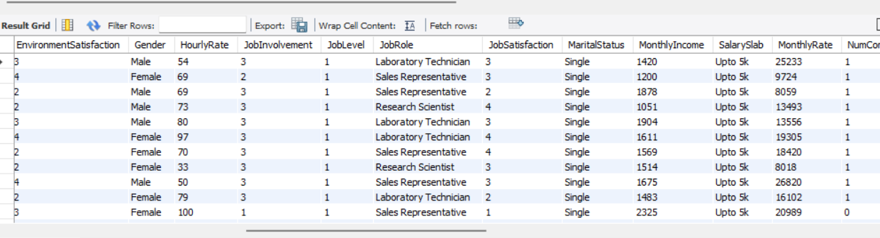

1. **Count of employees by department:**

SELECT Department, COUNT(*) AS Total_Employees

FROM HR_Analytics

GROUP BY Department;

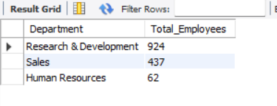

1. **Average salary by department:**

SELECT Department, AVG(MonthlyIncome) AS Average_Salary

FROM HR_Analytics

GROUP BY Department;

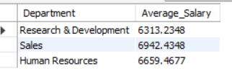

1. **Number of employees who left the company (attrition):**

SELECT COUNT(*) AS Attrition_Count

FROM HR_Analytics

WHERE Attrition = 'Yes';

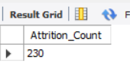

1. **Gender distribution in the company:**

SELECT Gender, COUNT(*) AS Gender_Count

FROM HR_Analytics

GROUP BY Gender;

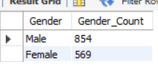

1. **Top 5 highest-paid employees:**

SELECT EmpID, Salary

FROM HR_Analytics

ORDER BY Salary DESC

LIMIT 5;

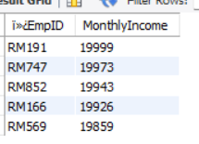

1. **Average experience by job role:**

SELECT JobRole, AVG(TotalWorkingYear) AS Avg_Experience

FROM HR_Analytics

GROUP BY JobRole;

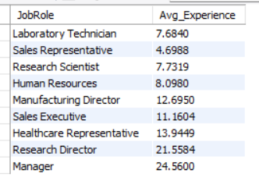

1. **List of employees older than 50:**

SELECT EmployeeID, EmployeeName, Age

FROM HR_Analytics

WHERE Age > 50;

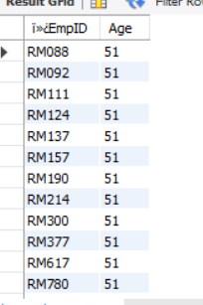

1. **Departments with more than 10 employees:**

SELECT Department, COUNT(*) AS Total_Employees

FROM HR_Analytics

GROUP BY Department

HAVING COUNT(*) > 10;

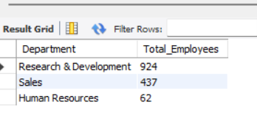

1. Employees earning above the company average salary

SELECT EmpID , MonthlyIncome

FROM HR_Analytics

WHERE MonthlyIncome>(select avg(MonthlyIncome) from HR_Analytics);

